Group 7 Project Task: Web Server Vulnerability Assessment
Executive Summary: A comprehensive vulnerability assessment would be conducted on http://147.93.57.86/ web server. Different tools such as whois, nslookup, nmap, Google Dorking, DNSDumpster, Securityheaders, ipleak, CVE and crt.sh were used to search for unauthorized access, information leakage, exposed services, and weak subdomain security. Screenshots of these findings and recommendations will be discussed.
A passive reconnaissance was done on http://147.93.57.86 to gather information about the website.
Findings
1. Directory and File Discovery
i. Identify hidden directories, admin panels, configuration files, or sensitive endpoints.
Started out by using Whois command using 147.93.57.86 did not find any results about the website including the name of the organisation.
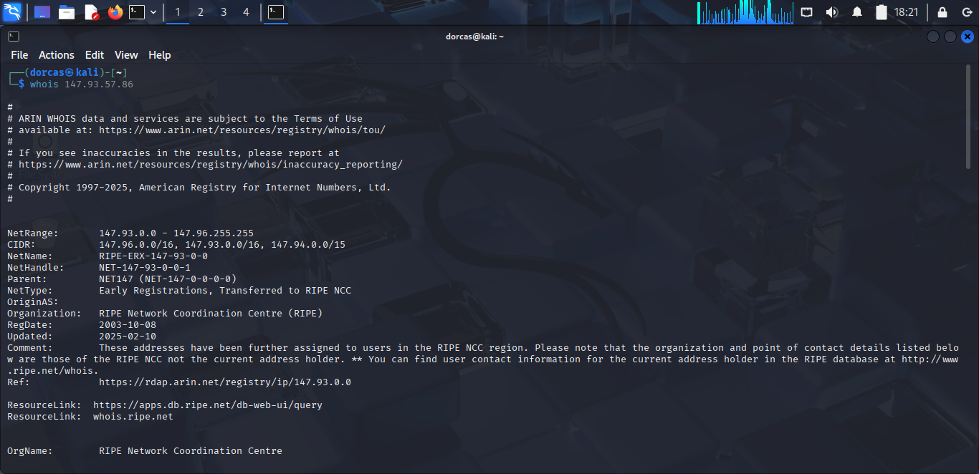

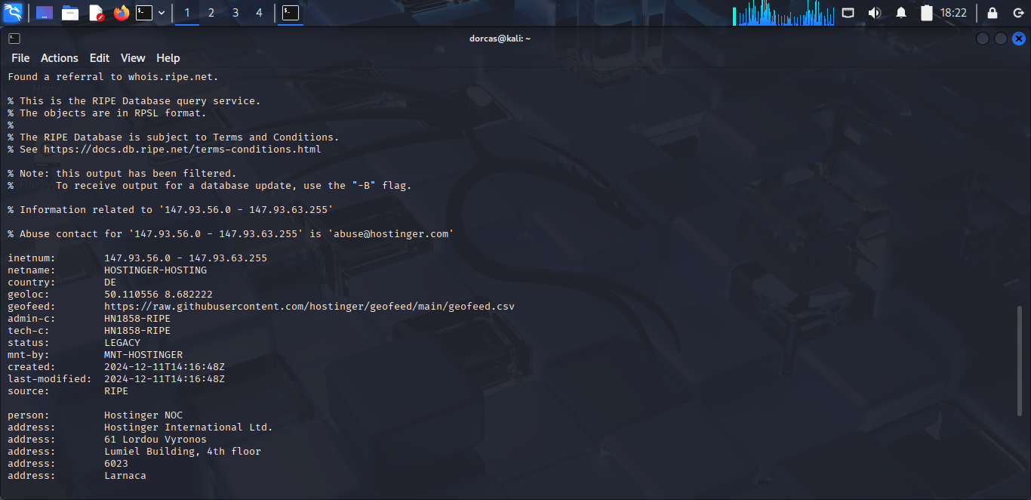

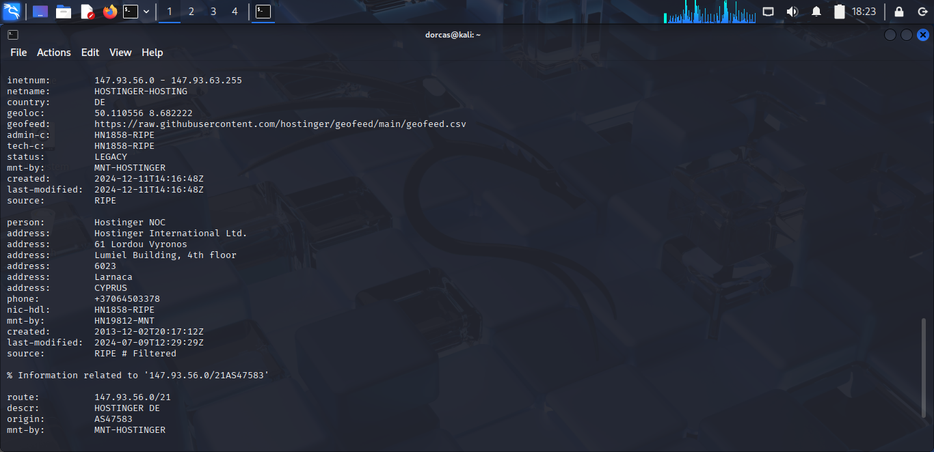
Used nslookup 147.93.57.86 command to see if I can get any information, I got communication error message and the name of the organisation is srv706902.hstgr.cloud
Went on to use nslookup 147.93.57.86.au although it gave communications error and two subdomains.
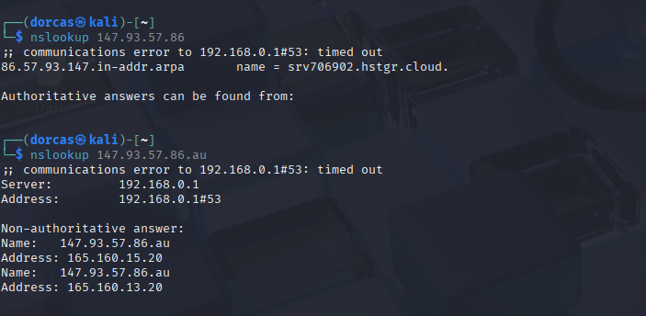
Nmap scan showed no vital report for srv706902.hstgr.cloud
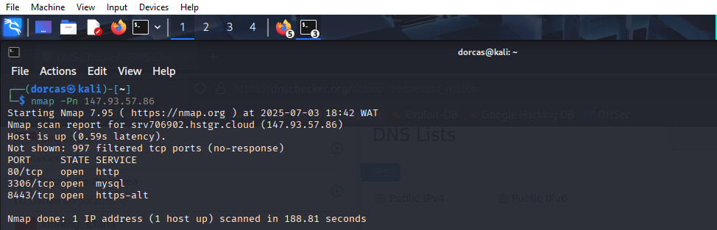

Google Dorking was used to access Srv706902.hstgr.cloud and there was no file or directories found.
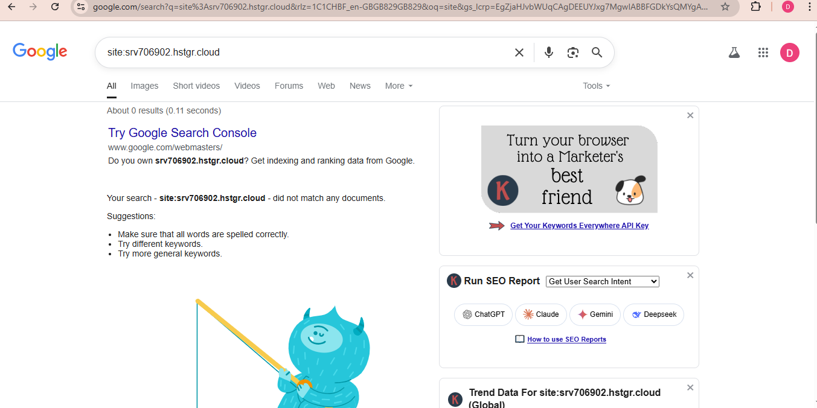
No admins panel found
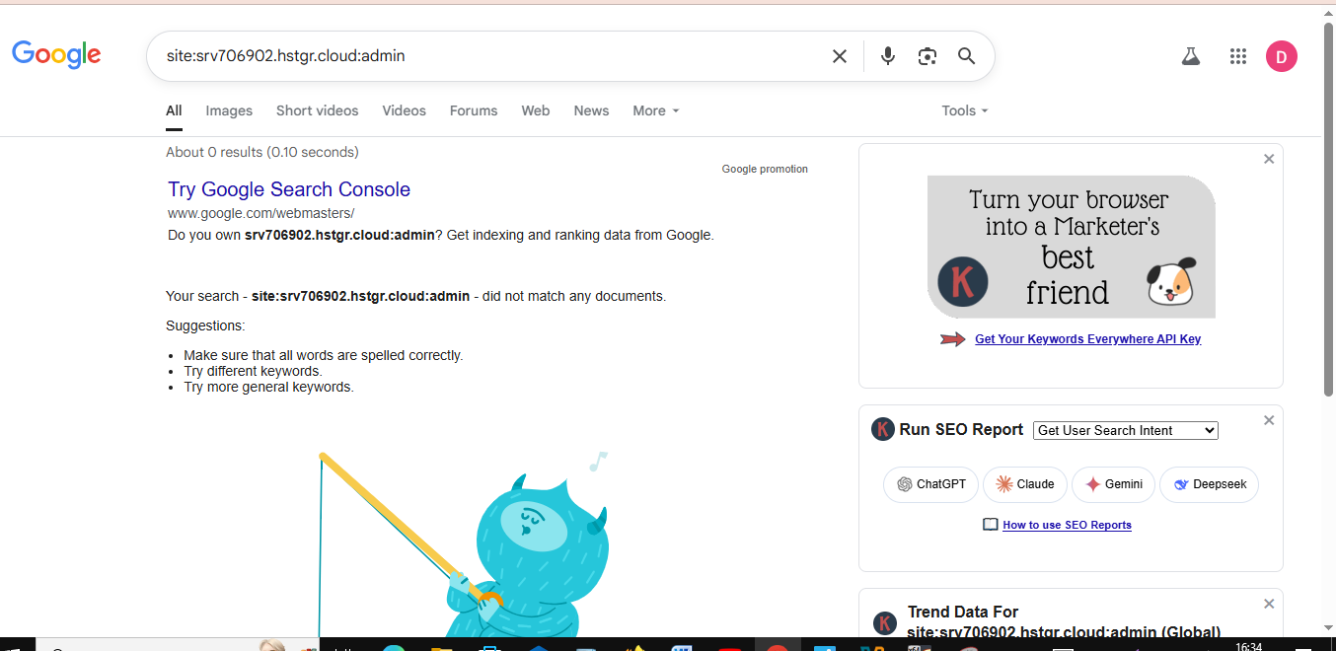.

ii. Check for exposed backup files, development scripts or testing environments.
No exposed Backup files found.
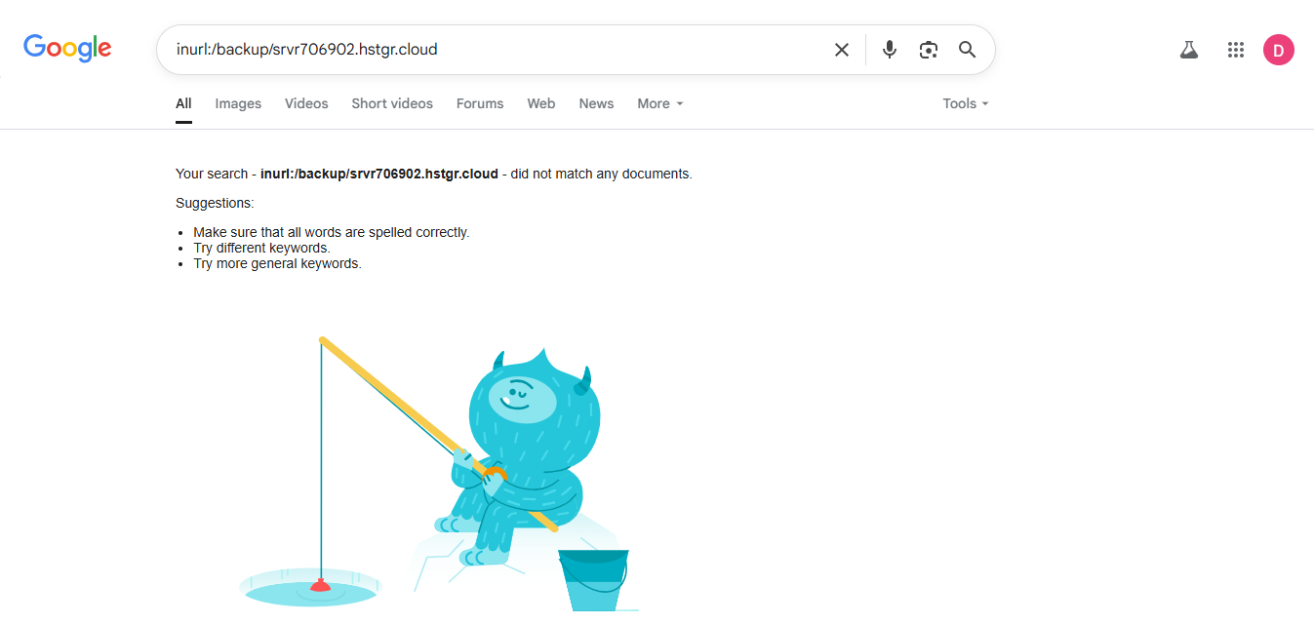
Development script
No development script was found
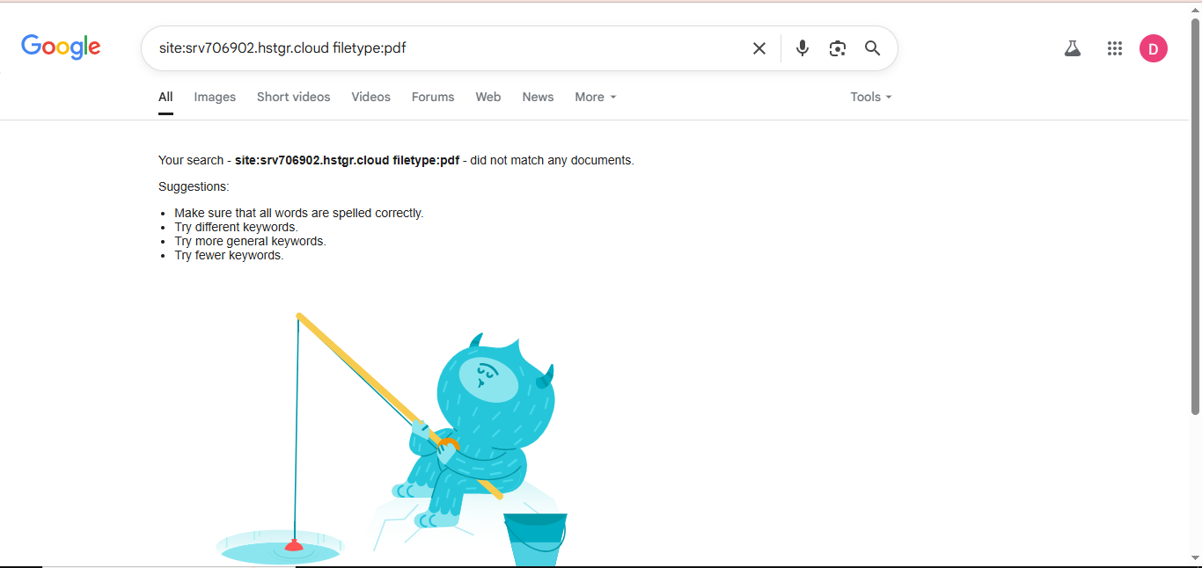
2. Domains and Subdomains Enumeration
- Identify any active or inactive subdomains linked to the server or its DNS records
The two Subdomain IP addresses was ping, and as shown below the subdomains are not active.
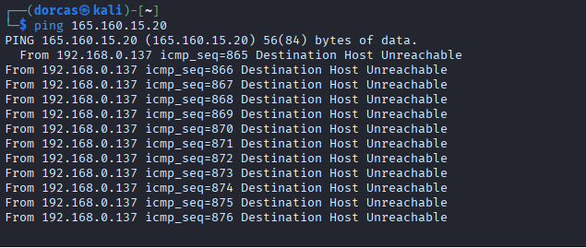

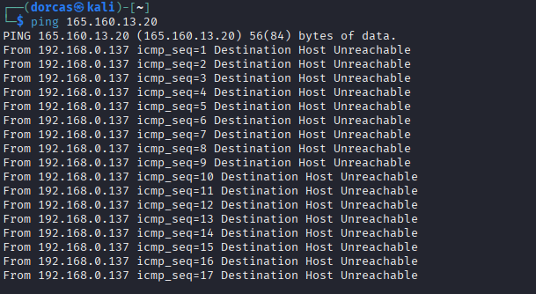
- Check if any subdomains are misconfigured or pointing to third-party services
Used DNSDumpster to check if the Subdomains were misconfigured. As seen below it was not misconfigured.
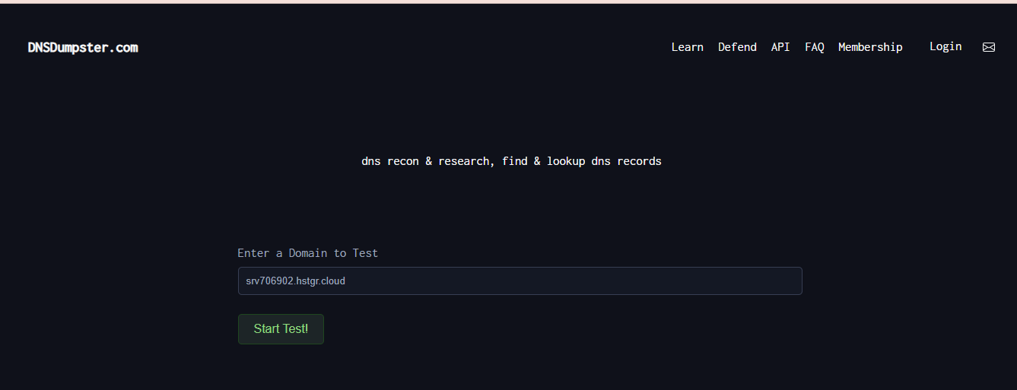
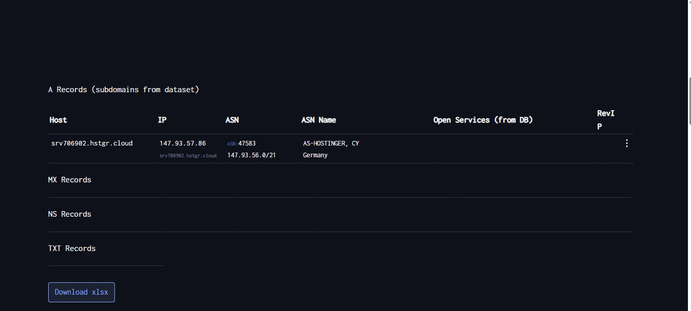
iii. Attempt subdomain takeover where possible and document steps taken.

3. Misconfiguration Analysis
Server misconfigurations such as:
- Open directories – No open directories.

- Missing or weak HTTP security headers

Strict-Transport-Security, Content-Security-Policy and Permissions-Policy are the missing headers found on srv706902.hstgr.cloud site.
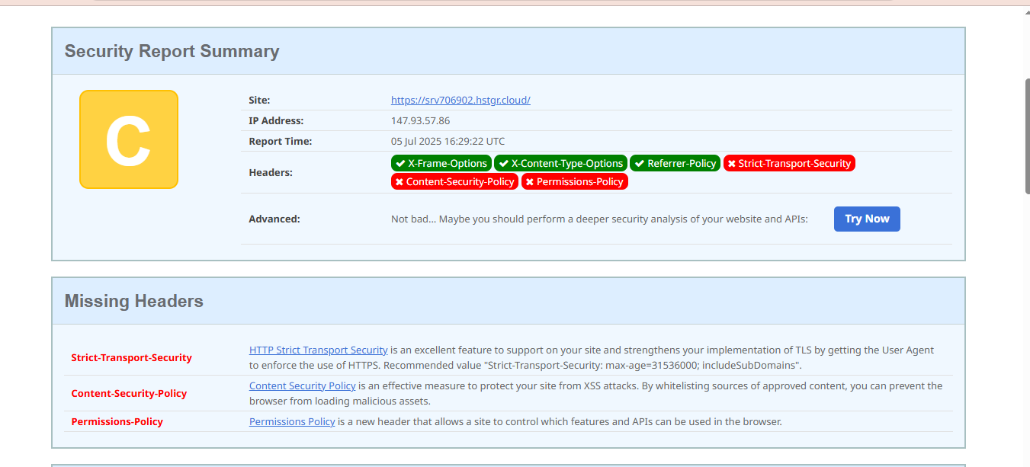

- Leaked internal IP addresses or server info
Below are the internal leaked IP addresses found
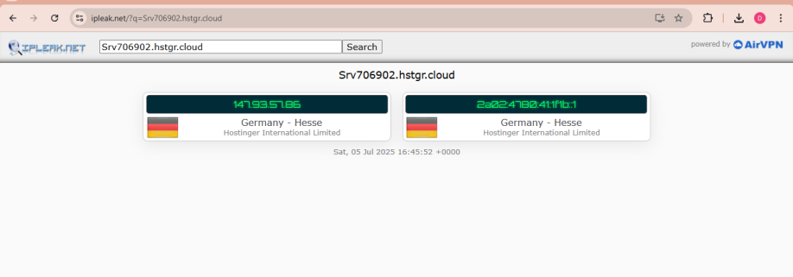

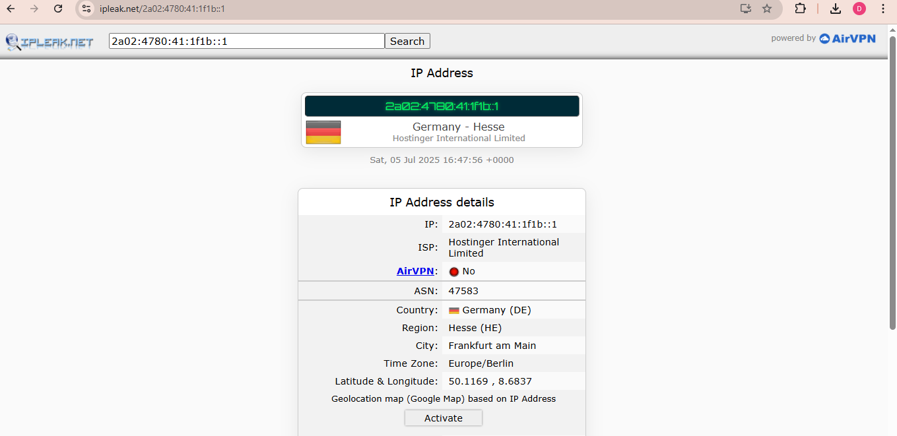
Permission-Policy showed only one vulnerability on CVE website
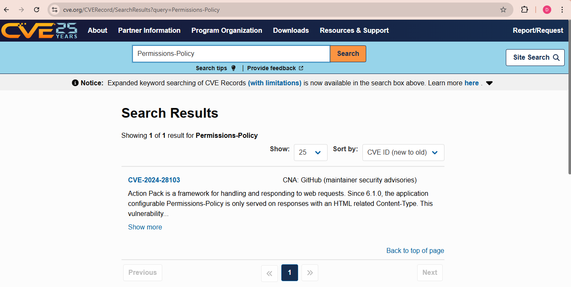

- Out-dated web technologies in use
HTTP Strict Transport Security, Content-Security-Policy, and Permissions-Policy is an out-dated web technologies that was used.

4. Vulnerabilities Identification
i. Detect any signs of outdated components, known exploits, or vulnerable web applications.
HTTP is out-dated and known vulnerable web application. Use Common Vulnerablities and Exposures (CVE) website to check HTTP Strict Transport Security.
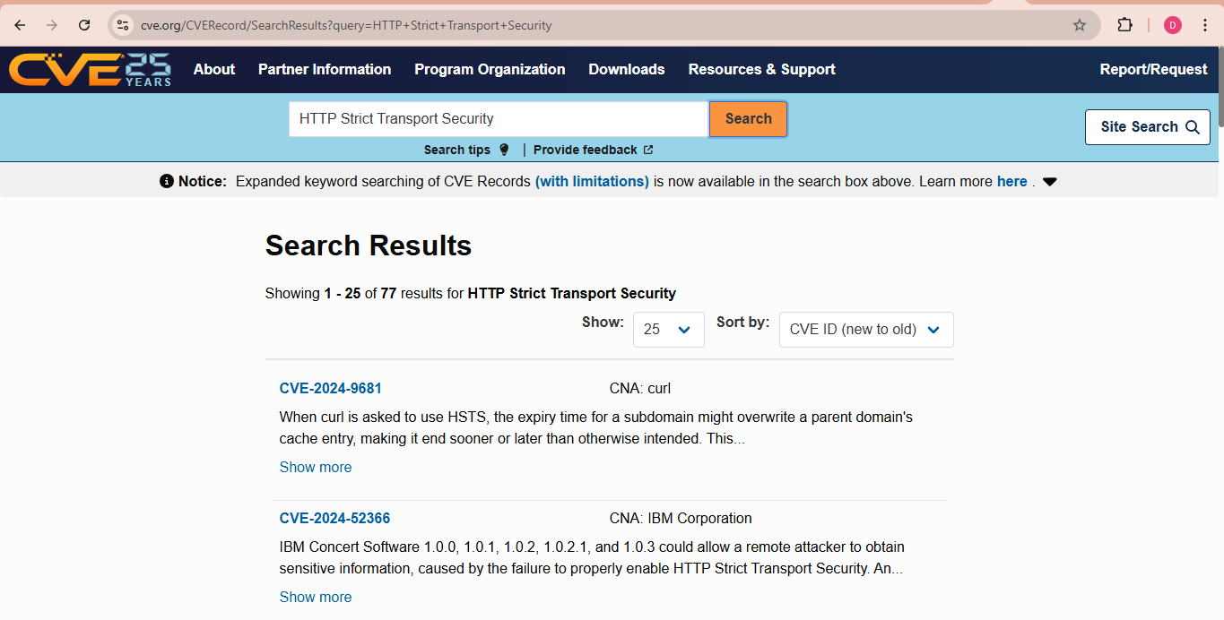
Content-Security-Policy
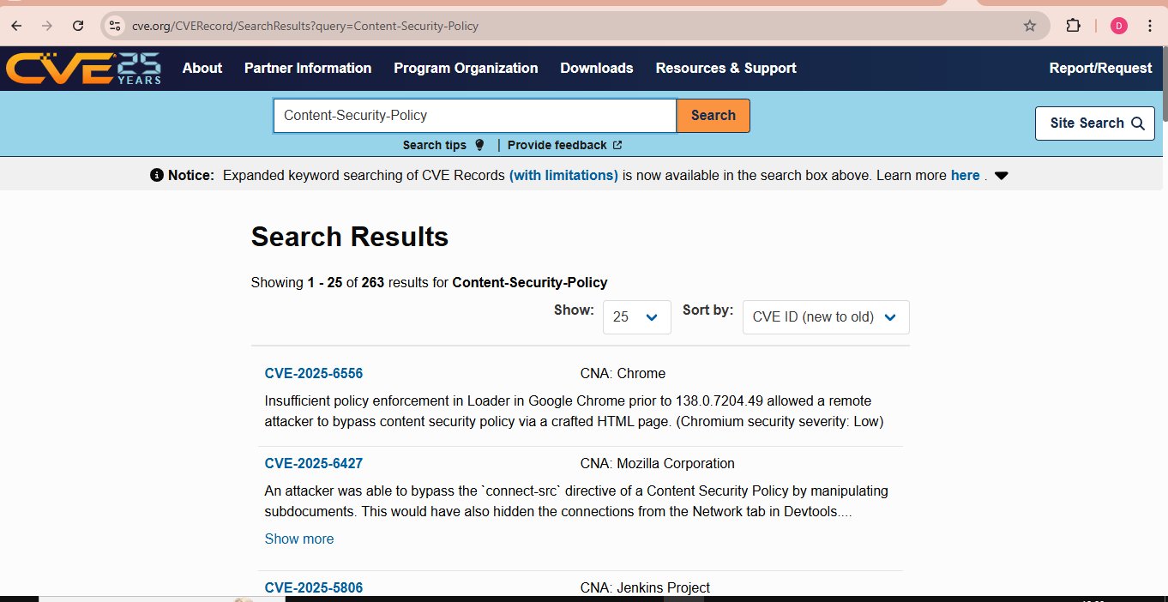
A result was displayed for Permission-Policy on CVE website.

ii. Pay attention to authentication weaknesses or exposed login portals

iii. Look for indicators of default credentials or public access to restricted resources
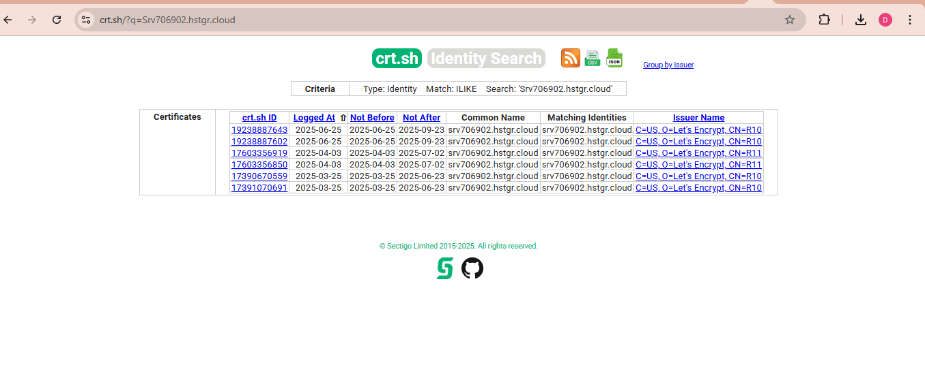

Results for http://147.93.57.86/
 | Google Dorking | Nmap | DNSDumpster | SECURITY HEADER | IPLEAK | CVE | CRT.SH | nslookup
Directory and File Discovery | No | No |  |  |  |  |  | No
Domains and Subdomains Enumeration |  |  |  |  |  |  |  | Yes
Misconfiguration Analysis |  |  | No
Vulnerabilities Identification |  |  |  | Yes | Yes | Yes | No

Recommendations
1. Strict-Transport-Security - Consider configuring Srv706902.hstgr.cloud web server by adding Strict-Transport –Security header, set the max-age directive, include the SubDomains and preload.
To configure Apache (VirtualHost) use this code:
Header always set Strict-Transport-Security “max-age=31536000; includeSubDomains; preload”
To configure Nginx, add the following code to server block add_header Strit-Transport-Security “max-age=31536000; includeSubDomains; preload”
Ensure to test and verify by pressing F12 to check if Strict-Transport-Security header response is present in HTTPS. Scan the website using online tools for misconfigured or missing headers.
2. Content-Security-Policy – It is imperative to have a very strong Content-Security-Policy (CSP) as it prevents against cross-site (XSS) attack. Use restrictive default default-src ‘self’ to limit contents from loading into the website.
Incorporate report-only mode policy by using the command code Content-Security-Policy-Report-Only to monitor header violations without blocking content.
Apply hashes for scripts and styles by using script-scr or style-scr directive including the HTML tags.
Be specific with the directives by listing out the domains and protocols e.g font-src, media-src, etc
3. Permissions-Policy – Configure the Permission-Policy header in the web server response. Disable unused features to reduce website attack, restrict features such as camera, microphone, and location to prevent malicious actors from gaining access to sensitive information.
Conclusion
In conclusion, always ensure that your web server applications are configured properly to avoid threat actors from exploiting the web server.

